Overview
Github: https://github.com/Michal1323/IoTCARelease
The Care Tracker app is an application that praises security only asking for protection in return. The motto when starting this project was providing care within the home and on the outside and with the help of IOT we have been able to simulate such progress. Elements of our application includes the use of Raspberry Pi, PIR sensors, Piezo Buzzer and 5 Female/Female Jumper wires to allow motion to be sensed. In relation to project, we want motion to be sensed whenever someone walk passed the sensor to let us know where about in the household or outside the household they could have been. We would be able to tell this with the use of sequences such as (please refer to architecture diagram)
Sequences | Outcomes
Backdoor Pi -> Hallway Pi | Living room
Bedroom Pi -> Front Door Pi | Left the House but if we added a Cron of 10 mins then we have known that he’s left his house for a period of time
Front Door Pi -> Hallway Pi/Bedroom Pi | This sequence can show that the user has entered the home
Hallway Pi - > Backdoor Pi | Left the House through the back but if we added a Cron of 10 mins then we have known that he’s left his house for a period of time
These sequences gives us a indication of where the client could be, with this information carer is able to have an idea of what the client is doing. This data is being hosted on AWS server and allows the carer to view if motion is detected with the option of the 4 PI. We detail this more in the Video.
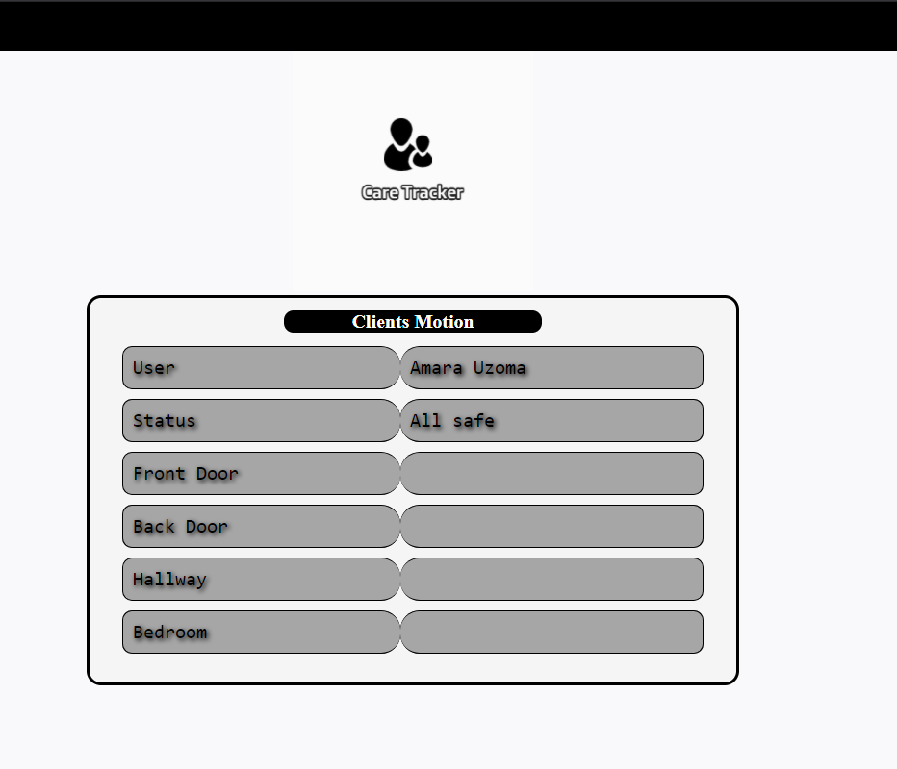

The System Architecture
  - Hardware

Hardware | Task
Raspberry pi zero | Small sized computer. Project creation.
5 Female/Female Jumper wires | Making wire harnesses.
PIR Sensor | Detect movement in the surrounding area.
Piezo Buzzer | Alerts when PIR Sensor detects movement.

Bedroom & Hall-way Sensor
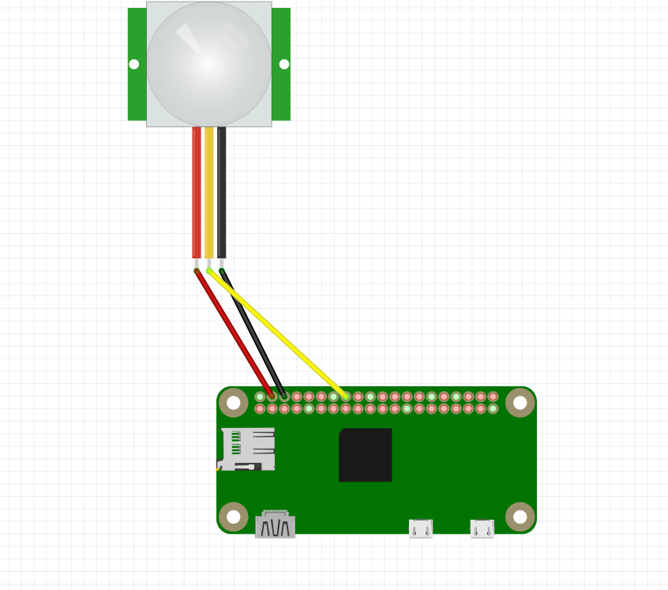

- Red wire is connected to Pin 4(5V power) & (3-5VDC Power)
- Yellow wire is connected to Pin 16(GPIO 23) & (Digital OUT)
- Black wire is connected to Pin 6(Ground) & (Ground)
Front door & Back door Sensor
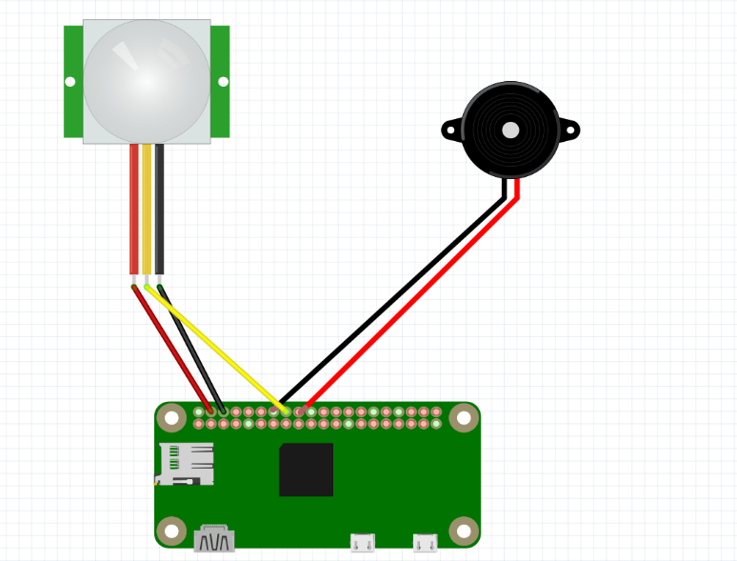

Sensor
- Red wire is connected to Pin 4(5V power) & (3-5VDC Power)
- Yellow wire is connected to Pin 16(GPIO 23) & (Digital OUT)
- Black wire is connected to Pin 6(Ground) & (Ground)
Piezo Buzzer
- Black wire connected to Pin 7(Ground) to Ground
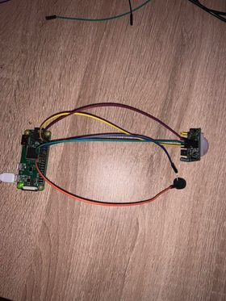
- Red wire connected to Pin 18 to GPIO 24

1.2 The Server
Originally, we only hosted or app on a localhost to see if its running meaning I can only connect to mine alone which is not the most helpful and defeats the point of client as they aren’t able to communicate. We want to be able to access the PIR buzzer. We want to be able to access the sensor from anywhere also. This is where PubNub and AWS server comes into play.

PubNub
We want our client to be able interact with the application whether that using a browser or a phone and PubNub supplies that. This is a publish subscribe service which allows someone to publish to a channel and if you are subscribed to the channel. In the case of our project (Care Tracker App), The Carer would be the one viewing the application, are 4 pi sensors are based the location below and they will be able to pick up data and publish on that channel for the carer to be able to view and be aware of the whereabouts of the client if they are subscribed to the channel.
- Bedroom
- Front Door
- Hallway
- Backdoor
Kitchen
Laundry Room
Toilet

Birds Eye view of the ideal placement of sensors (bungalow)

Living Room
Hallway
Bedroom (En-Suite)

- House Entry (Front Door, Back Door)
- Pi Sensor - Room Entry

AWS
AWS (Amazon Web Server) is a secure cloud services platform, offering compute power, database storage etc. The client(carer) sends a request to login which is sent to the AWS flask app and is only granted if they are authorized to. AWS host the server that we created using FreeNom. It allows for client to physically view the data flowing from the pi sensors to PubNub channel on the server.

How does this work?
In relation to our project. We do not want anyone being able to access the information of the client so we set up a login so that for the Carer can log in with her details. This would be in the form of a Login request. This is sent from the client side to the AWS server. They can login in using Facebook and when they are logged in, Facebook will send back a user access token which would send a Login Response in the form of a index.html. Once they are in, they see the index.html. This shows if the connection is live between the sensors and the server and shows the motion and where the motion is detected.

How does data flow?
If one of the four of the sensors goes of it updates the server and it gives the client(carer) an idea of where the user could be but beforehand the sensor picks up that someone is around, it then converts that into to data for it to be published to the channel that it subscribed to. The publish channel being PubNub sees this and logs it within its channel for the subscribers to see if authorized with an authorization key but this is all in the request of the client(carer). At the same time, the Flask App is being hosted on AWS. This allows the client(carer) to view the server and see the motion that is picked up when the sensors goes-off.

1.3 Security
Creating a new User on Raspberry Pi.
Our raspberry pi is exposed to the internet with private information. Changing the default user secures the pi so that unauthorized users can’t use default pi login details.

Adding a new user.
- All raspberry pi’s come with default username pi and the password raspberry
To add a new user in raspberry pi we used sudo adduser takudzwa. A brand new password is then asked to be entered for the user just created. The new user profile now has a home directory at /home/takudzwa/.
To add more security to our pi: We added our profile to the sudo group. This allows to give sudo permissions using the command:
- sudo usermod -a -G adm,dialout,cdrom,sudo,audio,video,plugdev,games,users,input,netdev,gpio,i2c,spi takudzwa.
To make sure sudo forces a require password before our application is ran we used: sudo visudo /etc/sudoers.d/010_pi-nopasswd and changed the user entry to pi ALL=(ALL) PASSWD: ALL.

Webserver Security
To secure the webserver it had to be changed from a HTTP to HTTPS. The first action to perform the security of the webserver is to add an inbound rule that accepts HTTPS on any port. Once the inbound rule is added then a hosted zone is added in route 53. The hosted zone being created is of type A. To then check if this worked we go to ssllabs.com and if the outcome is green then the server has been validated and secured.

Password Security
The command mysql_secure_information is used to secure the database with a password is typed it returns a measure of strength of your password which can be ranging from weak, medium, strong. They also give us a range of options also once logged in such as
- Change the password with a (Y/N) function
- Remove anonymous users
- Allows root login remotely
- Remove Test database to access
- Reload privilege tables

1.4 The database
The database that was used was a MySQL database that was linked to the aws server. The database instance was created, and a table called CareTrackerApp was created. The care tracker app contains a user table for now as the implementation of the motion sensor proved to be more difficult that originally taught and there was limited time with the whole setup. When the user creates a login instance with Facebook they are redirected to the Facebook page that should allow them to login but seeing that the app is only in development the only user that could log in is the person with the developer account from Facebook that created the Facebook instance. When that person logs in the server automatically creates a user instance for the person.
This user is a site admin and can see who else is online at the same time and can grant read and/or write privileges. The user data that is stored to the database is the id that is automatically generated by the database that auto increments when you add another user, user id which is the users personal Facebook sign in id instance, the authorisation key that was used to sign in to the site, the login status(1 if logged in and 0 if logged out). It also includes the read privileges and another field for write privileges. The database is secured with a password that was set up to have a requirement of average strength (this does not include words out of a specific dictionary).
The password strength for our MySQL server is 50 and we decided that this would be strong enough for the time being. The aws server and our website can read the database and pull out the required fields as shown in the screencast. The admin can see who the people that are online are and can change their read and write privileges of a chosen user that is currently online. The authorisation key that is stored in the database is hashed and salted so that it cannot be cracked easily and adds to the security aspect of our app.
The myDB.py file connects to our database and reaches the desired table. In this file I also implemented functions that can alter the database or retrieve certain instances of the database. This file will also be used further on down the line when we need to connect the two tables together when we need to get specific logs of the motion sensors from the database. The motion sensors database will contain the 4 motion sensors and will have instances for weather the motion sensor is alive or not, the timestamp of when the motion sensor last fired and the location of the sensor inside the house along with an id of the sensor.
This data will then be used to gather the amount of times that the client has left the house or if he is waking up at night and walking around the house. This implementation proved to be difficult for us at this stage of the project and this will be implemented in the beta release as the main constraint that held us back was lack of time.

